SMART CAR PARKING SYSTEM

* NAME : ARUN KUMAR R
* REG NO. :9530211060O9
* COLLEGE CODE :9530
* COLLEGE NAME :ST. MOTHER THERESA ENGINEERING

COLLEGE

NAAN MUDHALVAN:au953021106009

Introduction to Smart Parking

smart parking is a modern technological solution aimed at revolutionizing the way we approach parking in urban and suburban environments. As cities around the world face increasing challenges related to traffic congestion, limited parking spaces, and environmental concerns, smart parking systems have emerged as a promising answer to these issues. Smart parking leverages a combination of advanced technologies such as sensors, data analytics, mobile apps, and automation to provide a more efficient and user-friendly parking experience. The key idea behind smart parking is to optimize the utilization of parking spaces, reduce the time and fuel wasted in the search for parking, and enhance the overall urban mobility and quality of life. In a smart parking system, sensors are installed in parking spaces to monitor their availability in real-time. This data is then relayed to users through mobile applications or digital displays, allowing them to easily find and reserve parking spots. Additionally, smart parking solutions often include features like automated payment systems and integration with navigation apps to guide drivers to available parking spaces. The benefits of smart parking extend beyond individual convenience. By reducing traffic congestion and the environmental impact of circling for parking, these systems contribute to improved air quality and reduced emissions. They also have the potential to boost revenue for municipalities or private operators through dynamic pricing and efficient enforcement. Furthermore, smart parking aligns with broader urban development goals by enhancing safety, promoting sustainable transportation alternatives, and integrating with other aspects of urban infrastructure, such as public transportation and city planning. In this age of increasing urbanization, where efficient use of space and resources is paramount, smart parking is a critical component of the smart city concept. It represents a proactive and innovative approach to tackling the parking challenges that accompany urban growth, making cities more livable and sustainable for residents and visitors alike. As technology continues to advance, the future of smart parking promises even more innovative and intelligent solutions to improve the way we park and move within urban environments.

Project Objectives

Optimize Parking Space Utilization: The primary goal of smart parking is to maximize the use of available parking spaces. This involves reducing congestion and minimizing the time and fuel wasted by drivers searching for parking spots.

Reduce Traffic Congestion: By guiding drivers to available parking spaces and reducing the time spent circling for a spot, smart parking systems aim to alleviate traffic congestion in urban areas. This can lead to reduced emissions and improved air quality.

Enhance User Convenience: Smart parking systems should make it easier for drivers to find, reserve, and pay for parking. Mobile apps, online booking, and real-time availability updates contribute to a more convenient and user-friendly experience.

Improve Revenue Generation: Many smart parking initiatives are designed to increase revenue for municipalities or private operators. This can be achieved through dynamic pricing, efficient enforcement, and improved space turnover.

Enhance Safety and Security: Smart parking solutions can incorporate security features like surveillance cameras and emergency call buttons to enhance the safety of parking facilities.

Reduce Environmental Impact: Reducing the time vehicles spend idling and circling for parking spots can contribute to lower fuel consumption and emissions, thus helping to combat air pollution and climate change.

Promote Sustainable Transportation: Smart parking projects often aim to encourage the use of public transport, carpooling, and non-motorized modes of transportation by making these options more accessible and convenient.

Data Collection and Analysis: Gathering data on parking space utilization, traffic patterns, and user behavior is a key objective. Analyzing this data can help urban planners make informed decisions and optimize parking policies.

Enhance Accessibility: Smart parking should be designed to cater to the needs of all users, including those with disabilities, by providing accessible parking spaces and user-friendly features.

Integration with Urban Infrastructure: Smart parking systems should be integrated with broader urban infrastructure, including traffic management, public transportation, and city planning, to ensure a cohesive and well-coordinated approach to urban mobility.

Sustainability and Green Initiatives: Some smart parking projects may include the implementation of sustainable infrastructure elements like electric vehicle charging stations, solar-powered parking meters, and green urban design.

Economic Development: In certain cases, smart parking projects are expected to stimulate economic growth by making it easier for people to access businesses and attractions in urban areas.

Enforcement and Compliance: Ensure that parking rules and regulations are effectively enforced through automa

Feedback and User Engagement: Smart parking projects should encourage user feedback and engagement to continuously improve the system based on user experiences and preferences.

Scalability and Adaptability: The system should be designed to adapt to changing urban needs and to be scalable as the city or area grows

IoT Devices :

1. ESP8266 NodeMCU

2. Ultrasonic Sensor

3. DC Servo Motor

4. IR Sensors

5. 16x2 i2c LCD Display

6. Jumpers

Devices Setup:

Setting up an IoT project using an ESP8266 NodeMCU board, ultrasonic sensor, DC servo motor, IR sensors, a 16x2 I2C LCD display, and jumpers involves several steps. I'll provide an overview of how you can set up this project, but please note that this is a complex project, and you may need to consult specific documentation and libraries for each component. Additionally, coding this project will require programming skills in platforms like Arduino IDE.

1. Gather the Required Components:

1. ESP8266 NodeMCU board.

2. Ultrasonic sensor (e.g., HC-SR04).

3. DC servo motor.

4. IR sensors (for object detection).

5. 16x2 I2C LCD display.

6. Jumper wires and breadboard.

7. Power supply for the servo motor if needed.

2. Connect the Ultrasonic Sensor:

* Connect the VCC pin of the ultrasonic sensor to the 3.3V output of NodeMCU.
* Connect the GND pin of the ultrasonic sensor to the GND of NodeMCU.

• Connect the TRIG pin of the ultrasonic sensor to a GPIO pin (e.g., D2).

• Connect the ECHO pin of the ultrasonic sensor to another GPIO pin (e.g.,• D3).

3. Connect the DC Servo Motor:

* Connect the positive (red) lead of the servo motor to the 5V output of NodeMCU.
* Connect the negative (brown) lead of the servo motor to the GND of NodeMCU.
* Connect the signal (orange/yellow) lead of the servo motor to a GPIO pin (e.g., D4).

4. Connect the IR Sensors:

* IR sensors are usually analog sensors. Connect the VCC and GND pins to 3.3V and GND on the NodeMCU.
* Connect the signal pin of the IR sensors to analog GPIO pins (e.g., A0 and• A1).

5. Connect the 16x2 I2C LCD Display:

* Connect the SDA (data) and SCL (clock) pins of the I2C LCD display to the corresponding pins on the NodeMCU (D1 and D2 on the NodeMCU, respectively).
* Connect the VCC of the I2C display to 5V on NodeMCU and GND to GND.

6. Write and Upload the Code:

Write the Arduino code to control your project. This code will involve reading data from the ultrasonic sensor, processing it, controlling the servo motor, and displaying information on the LCD. You'll also need code to handle IR sensor inputs if they're used for object detection.

7. Power Supply:

Make sure you have a suitable power supply for your servo motor, as the NodeMCU might not be able to provide enough power for it.

8. Assemble and Test:

Connect all the components, upload the code to the NodeMCU, and assemble the project. Test each component and ensure that the system functions as expected.

PYTHON CODE:

class ParkingSpot:

def _init_(self, spot_number):

self.spot_number = spot_number

self.is_available = True

self.car = None

def park_car(self, car):

Park a car in the parking spot.

if self.is_available:

self.car = car

self.is_available = False

print(f"Car {car} parked in spot {self.spot_number}")

else:

print(f"Parking spot {self.spot_number} is occupied.")

def retrieve_car(self):

Retrieve a car from the parking spot.

if not self.is_available:

car = self.car

self.car = None

self.is_available = True

print(f"Car {car} retrieved from spot {self.spot_number}")

return car

else:

print(f"Parking spot {self.spot_number} is already empty.")

return None

class ParkingLot:

def _init_(self, num_spots):

self.parking_spots = [ParkingSpot(i) for i in range(1, num_spots + 1)]

def park_car(self, car):

Park a car in the first available parking spot.

for spot in self.parking_spots:

if spot.is_available:

spot.park_car(car)

return

print("No available parking spots.")

def retrieve_car(self, spot_number):

Retrieve a car from the specified parking spot.

if spot_number < 1 or spot_number > len(self.parking_spots):

print("Invalid spot number.")

return

spot = self.parking_spots[spot_number - 1]

return spot.retrieve_car()

# Example usage

parking_lot = ParkingLot(10)

parking_lot.park_car("ABC123") # Park car with license plate "ABC123"

parking_lot.park_car("XYZ789") # Park car with license plate "XYZ789"

parking_lot.retrieve_car(1) # Retrieve car from spot 1

parking_lot.retrieve_car(2) # Retrieve car from spot 2

output of the code:

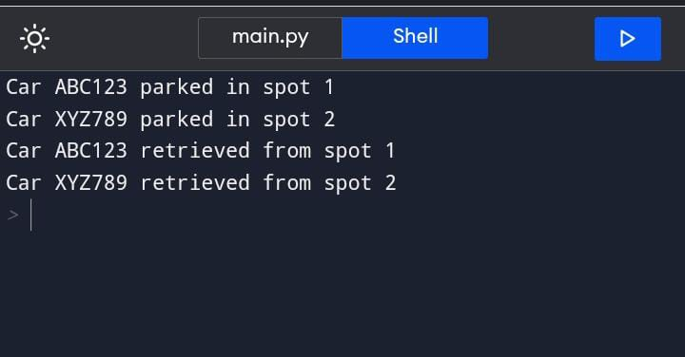

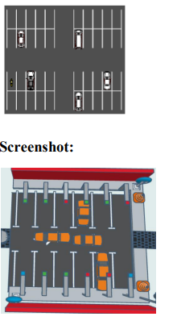

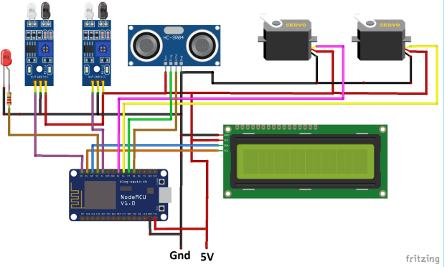

RESULT:

The circuit for automatic car parking system and the coding is run successfully

The functionality of the project is good

CONCLUSION:

As technology continues to advance, we can expect to see even more innovative and intelligent smart parking solutions in the future. These solutions will help to make cities more livable and sustainable for residents and visitors alike.This conclusion is concise, memorable, and relevant to the rest of the presentation. It summarizes the main points of the presentation, restates the thesis statement, and leaves the audience with a final thought about the future of smart parking.